Group A
- Which feature of OOP indicates code reusability?
  - Abstraction
  - Polymorphism
  - Encapsulation
  - Inheritance ✔
- Which of the following is not an access modifier?
  - Abstract ✔
  - Public
  - Private
  - Protected

- Encapsulation is a way of combining both data members and member functions, which operate on those data members, into a single unit. We call it a class in OOP generally. This feature has helped us modify the structures used in C language to be upgraded into class in JAVA and other languages. Show the process encapsulation in JAVA.
Answer:
The term encapsulation refers to data privacy. Encapsulation is achieved by using various access modifiers like public, private, protected and default.
In Java, to implement encapsulation, the members of the class defined are set to various access modifiers.
Public
If the member is public, the member can be accessed by any of its objects at different context. This modifier is by default chosen when no access modifier are given.
For example:
public class School {
public int classRooms;
public String [] teachers;
}
Here, the class School is public which means that this class can be accessed from any context. And the members classRooms and teachers also can be accessed by the object of the class School.

Private
If the member is private, the member can be accessed only within the class definition. Like the methods defined inside the class.
For example:
public class School {
private int classRooms;
public String [] teachers;
public void increaseClassRoom(){
this.classRooms++;
}
}
Here, the member classRooms is private which means that it is inaccessible by its objects. But the method increaseClassRoom() inside the class can access the member.
To access the private members, it can be done through the public methods defined in the class.
Protected
If the member is protected, the member can be accessed only within the class definition and within the class definition of its child classes.For example:
Institution.java
public class Institution {
private int classRooms;
private String [ ] teachers;
}
public class School extends Institution {
public void someMethod(){
this.classRooms ++ ;
}
}
Here, the School class is the child of Institution class. In Institution class, the classRoom variable is private. But it can be accessed by the members of School class inside the class definition itself of the School class. But still it cannot be accessed outside these two classes.

Group B
- Create a class named 'Student' with String variable 'name' and integer variable 'roll no'. Assign the value of roll no as '2' and that of name as "John" by creating an object of the class Student.
Student Class:
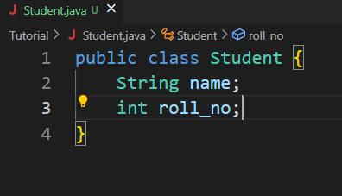
Main class
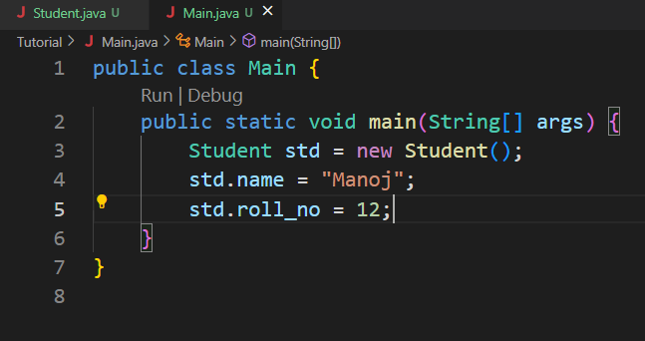

- A rectangle has the length of 6 centimeters and width 4cm. Create a method each to print the area and perimeter of the given rectangle.
Rectangle.java:
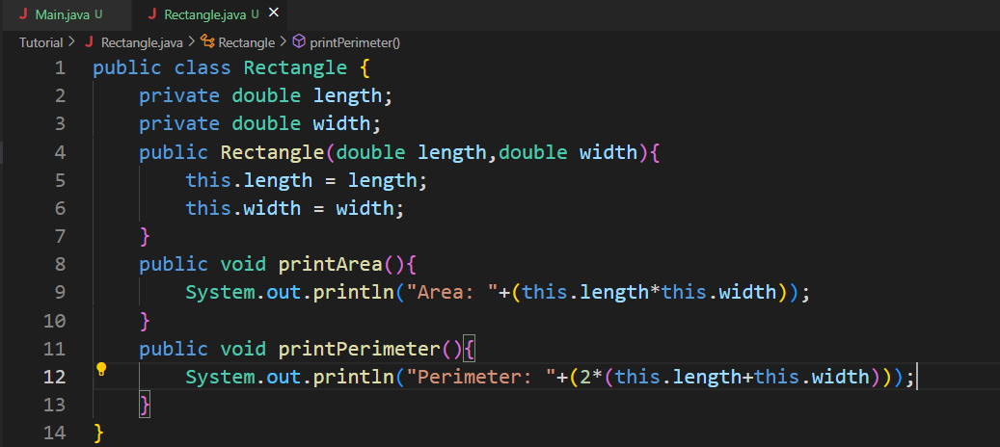

Main class:
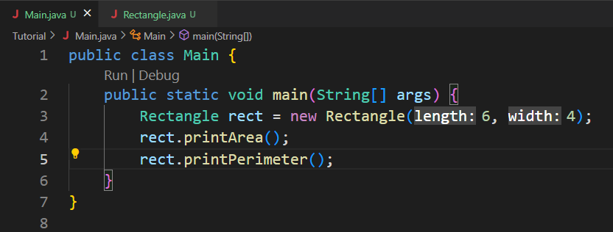
Output:
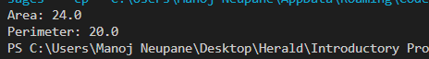

- Write a program to print the simple interest by creating a class named “Savings” taking the values of its Principle, Time, and Rate as parameters of a method named “Interest”.

Savings.java:
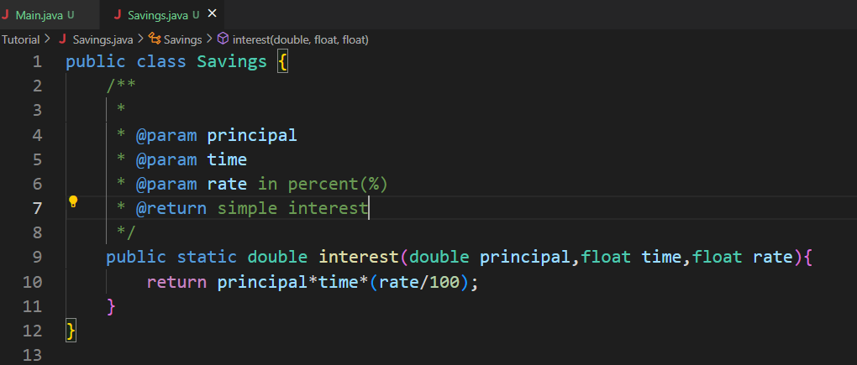

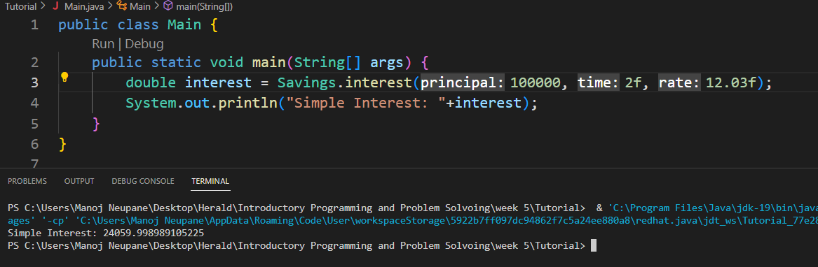

Since the interest method is static, no need to create the object of Savings class to access it.

Group C
- Write a program to find the sum of three numbers. Create a method findSum() of integer return type to print the sum.
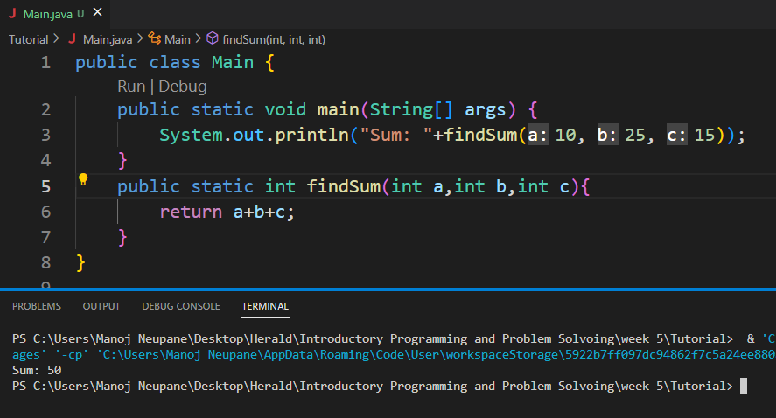

- Write the program to find the average of three input numbers by using a method returning a double value.
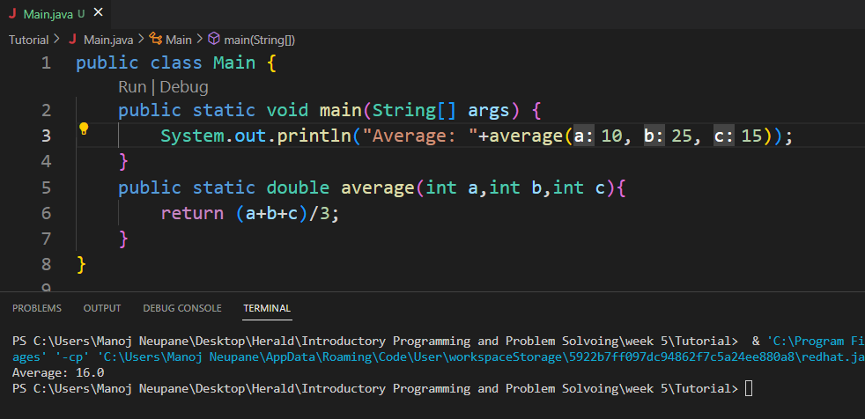

- Create a class named 'Employee' having the following members:
Data members:
  - Name
  - Age
  - Phone number
  - Address
  - Salary
It also has a method named 'printSalary' which prints the salary of the members. Now, assign name, age, phone number, address and salary to an employee by making an object of both of these classes and print the same.

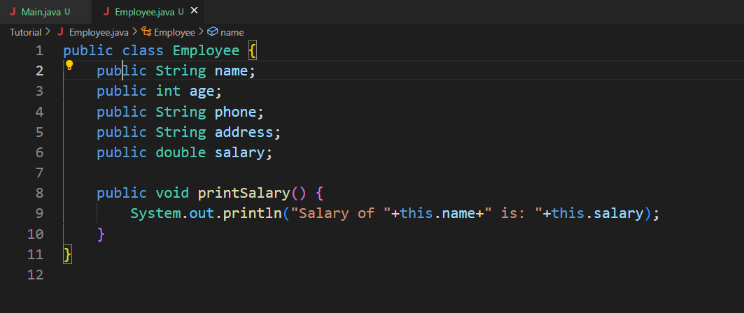

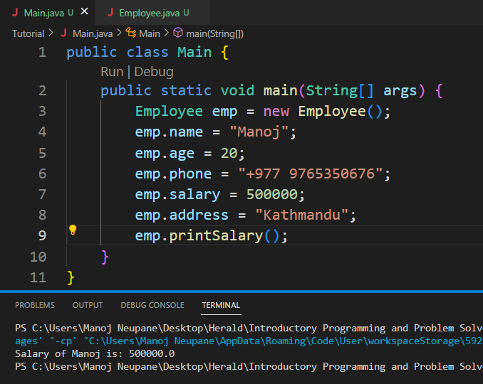

Group D
1. Create a simple calculator program using java OOP.
- Take two non-zero inputs.
- Create a method to print sum, difference, product, and quotient.
- Ask the user to choose between options (1-4) for sum, difference, product and divide operations.
- Give the user choice of another operation.
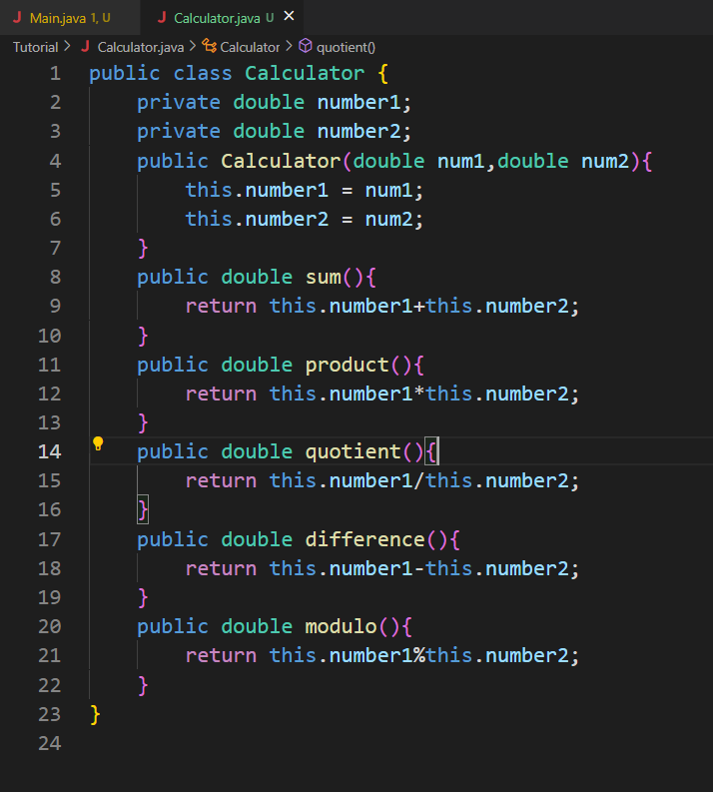

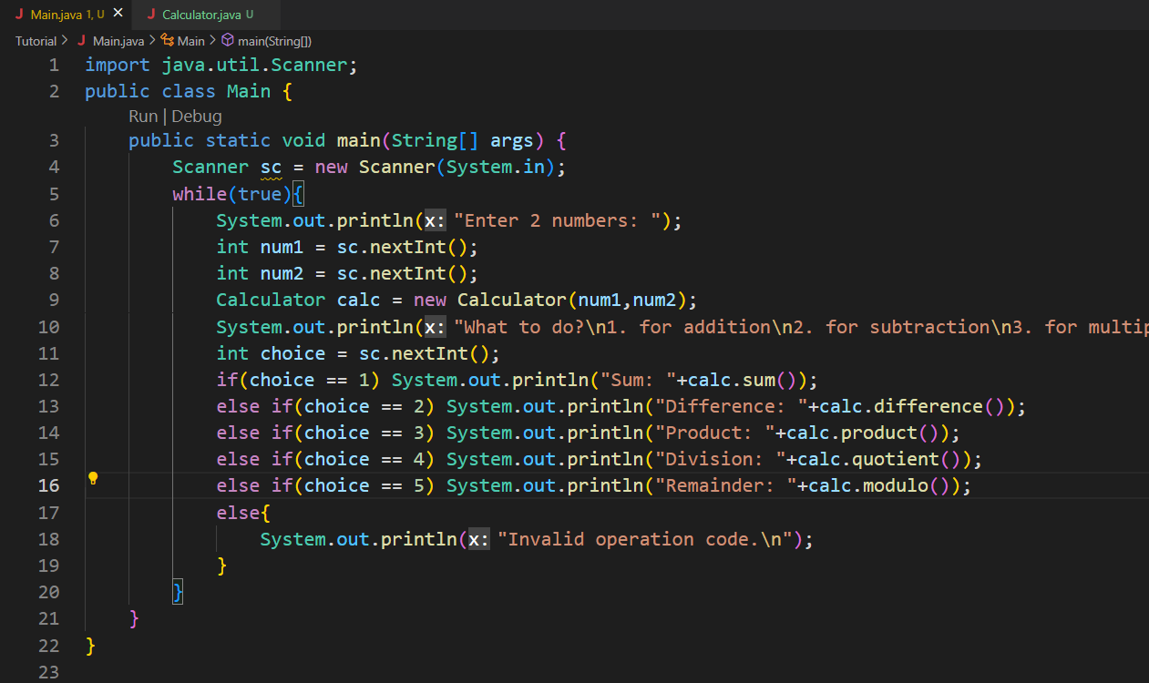

Output:
